Process Definition
A process is a program that is currently being executed.
It is an active entity because it includes:
- the program code,
- current activity,
- memory,
- CPU state, etc.
Example:
- A .exe file stored on disk = program
- When you run it in RAM = process

Four Components of a Process
A process mainly contains these 4 components:
- Program Code (Text Section)
  - The actual instructions of the program.
- Data Section
  - Stores global and static variables.
- Stack
  - Stores function calls, local variables, return addresses.
- Heap
  - Stores dynamically allocated memory during runtime.

Process States and Schedulars:- https://youtu.be/2dJdHMpCLIg?si=7-rEPdPlQ0DLbUDY

Context Switching
A context switch happens when the CPU switches from one process to another.
The operating system saves the current process state and loads the next process state so execution can continue correctly later.
The saved information is called the context.

What is saved during context switching?
Things like:
- Program Counter (PC)
- CPU registers
- Process state
- Memory information

Example
Suppose:
- Process P1 is running
- Time quantum ends
- OS pauses P1 and runs P2
The OS:
- Saves P1 data
- Loads P2 data
- CPU starts executing P2
This switching is called context switching.

Important Point
Context switching is an overhead because CPU spends time switching instead of executing processes.

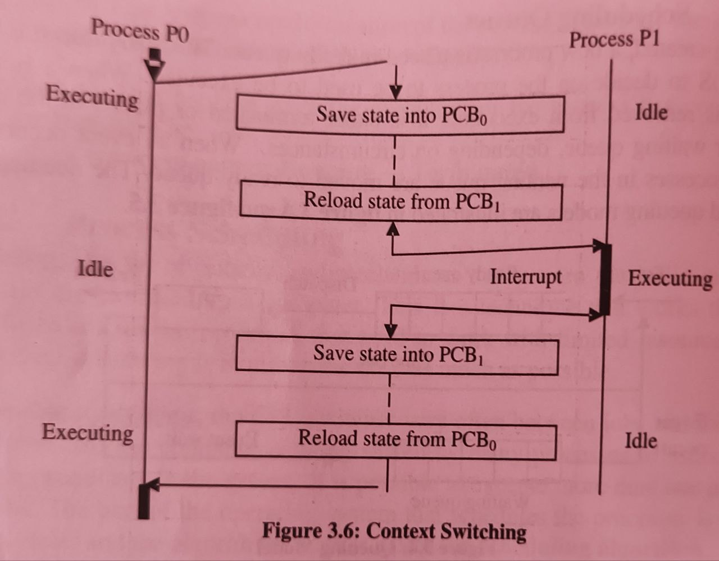

Process Control Block (PCB)
A PCB is a data structure used by the operating system to store information about a process.
It acts like the identity card/record of a process.
Each process has its own PCB.

Information stored in PCB

1. Process State
- Ready
- Running
- Waiting, etc.

2. Process ID (PID)
- Unique ID of process

3. Program Counter
- Address of next instruction

4. CPU Registers
- Current register values

5. CPU Scheduling Information
- Priority
- Queue pointers
- Scheduling data

6. Memory Management Information
- Base/limit registers
- Page tables

7. Accounting Information
- CPU usage
- Time limits

8. I/O Status Information
- Open files
- Devices allocated
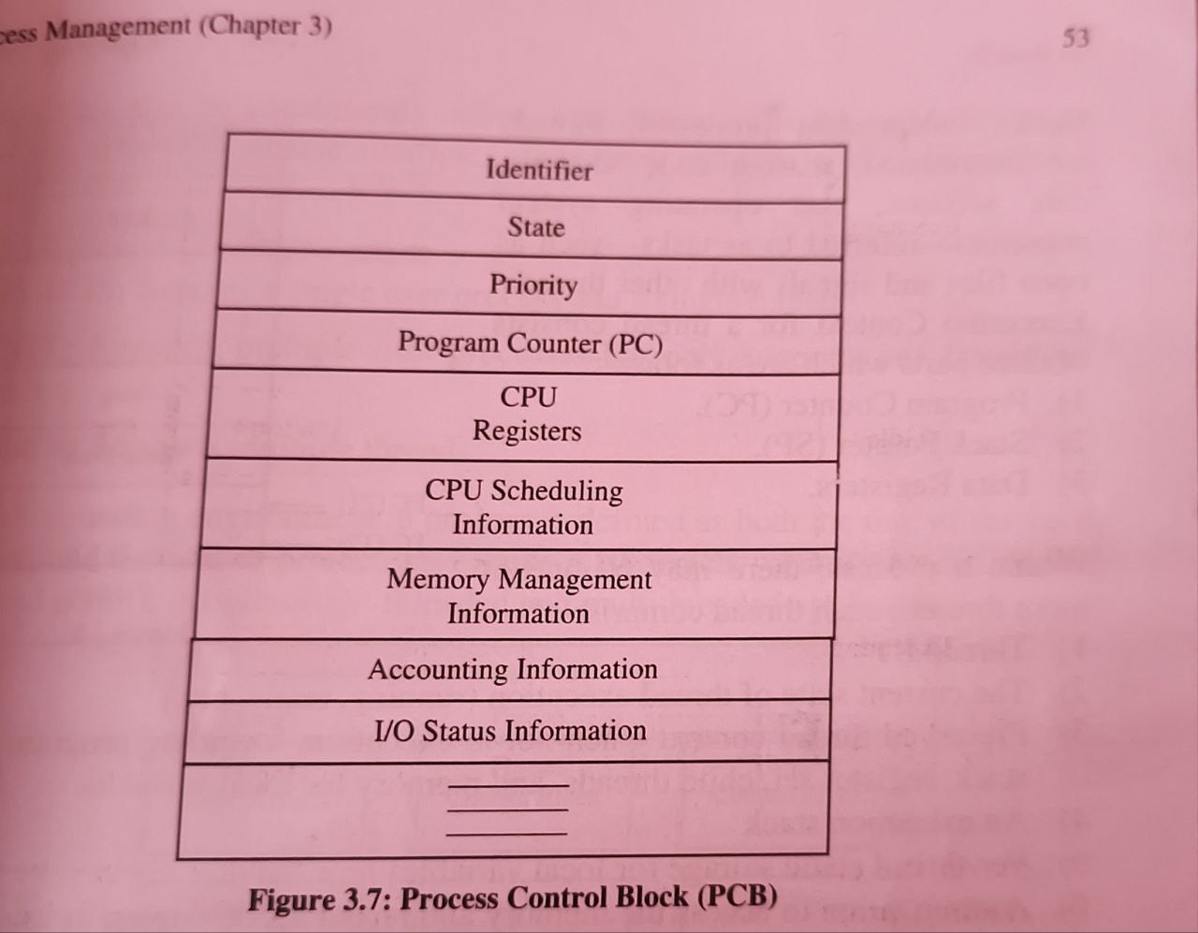

Thread
A thread is the smallest unit of CPU execution inside a process.
A process can have:
- one thread → single-threaded
- multiple threads → multithreaded
Threads of the same process share:
- code
- data
- memory
But each thread has its own:
- program counter
- registers
- stack

Example
In a browser:
- one thread loads webpage
- another plays video
- another handles user input
All work simultaneously inside one process.

Types of Threads
There are mainly 2 types:

1. User-Level Threads (ULT)
Threads are managed by the user-level thread library, not directly by OS kernel.

Features
- Fast to create and switch
- Kernel does not know about these threads

Disadvantage
If one thread blocks, entire process may block.

Example libraries
- POSIX threads
- Java threads (partly managed)

2. Kernel-Level Threads (KLT)
Threads are managed directly by the operating system kernel.

Features
- Kernel schedules each thread independently
- Better concurrency

Disadvantage
- Slower than user-level threads because kernel involvement is needed

Difference
User-Level Threads | Kernel-Level Threads
Managed in user space | Managed by OS kernel
Faster | Slower
Kernel unaware | Kernel aware
One blocked thread may block all | Other threads can continue

Multithreading Benefits
- Better responsiveness
- Faster execution
- Resource sharing
- Improved CPU utilization
- Parallelism/concurrency
CPU Scheduling Algorithems :- https://www.youtube.com/watch?v=zFnrUVqtiOY
CPU Scheduling Algorithems (terms):- https://www.youtube.com/watch?v=n7Owxwfr6Ko
FCFS CPU Scheduling:- https://www.youtube.com/watch?v=MZdVAVMgNpA
SJF CPU Scheduling:- https://www.youtube.com/watch?v=VCIVXPoiLpU
SRTF CPU Scheduling:- https://www.youtube.com/watch?v=hoN7_VMzw_g
ROUNDROBIN CPU Scheduling:- https://www.youtube.com/watch?v=TxjIlNYRZ5M

